Property Class SISCareer :

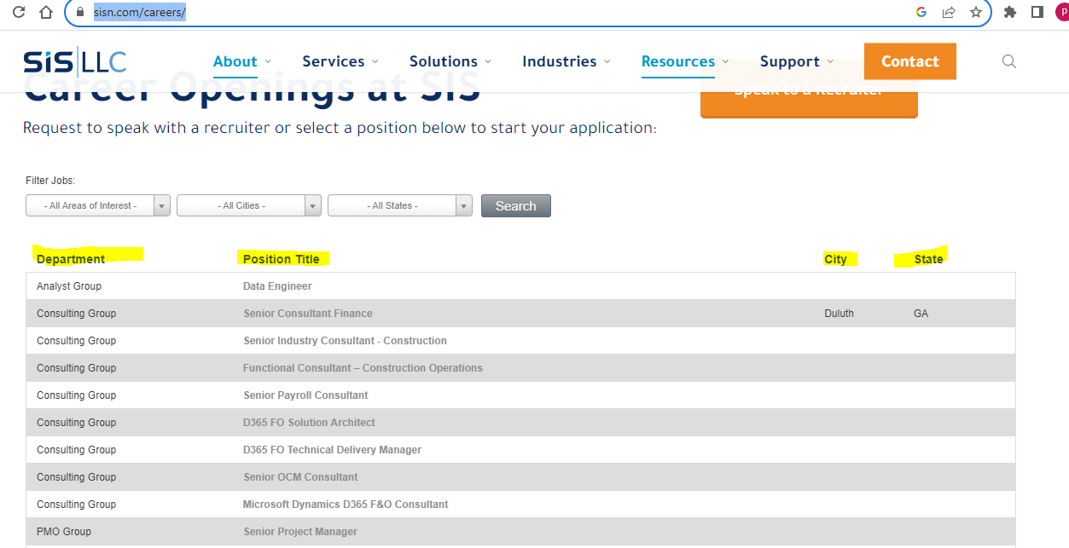

Property Class TrainBooking :

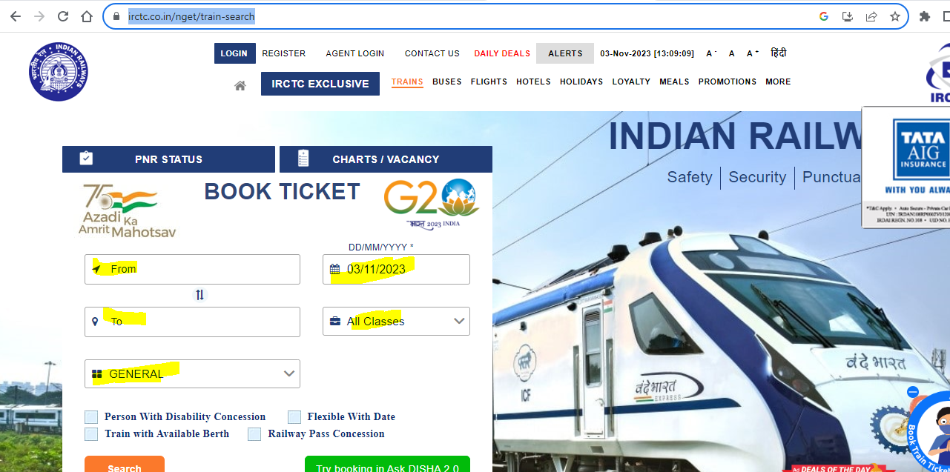

Contact Us

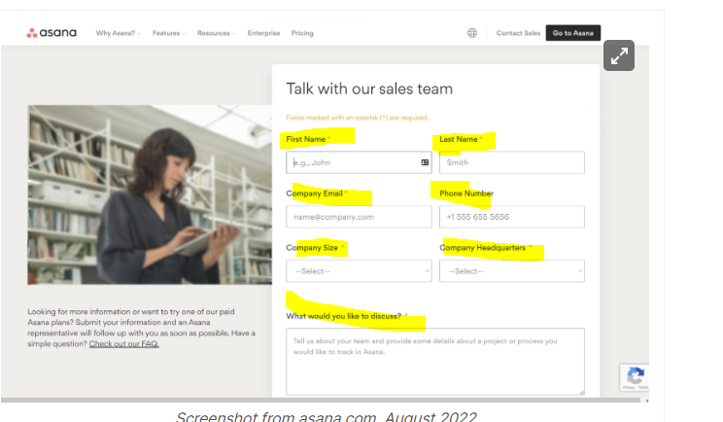

Property Class : Amazon Order

Property Class : Facebook and Friends Request

Property Class : SwiggyOrder

Property Class : RedBus Booking

Property Class : HotelBooking

Property Class : ToursAnd Travels

Property Class : Employee Registration

Notes :

static void Main(string[] args)

{

Console.WriteLine("inputUserName");

bool isLoginSuccess = false;

string inputUserName = Console.ReadLine();

Console.WriteLine("inputPassword");

string inputPassword = Console.ReadLine();

string[] Users = { "Gopi", "Ganes", "Kiran", "Namrata", "Allwn", "Priya", "Sneka", "Jenica" };

string[] Passwords = { "Gopi@123", "Ganes@123", "Kiran@123", "Namrata@123", "Allwn@123", "Priya@123", "Sneka@123", "Jenica@123" };

//for (int i=0;i<Users.Length; i++)

// {

// if (Users[i] =="input" && Passwords[i] == "userinput")

// {

// break;// true success and break .

// }

// }

foreach (string user in Users)

{

foreach (string password in Passwords)

{

if (inputUserName == user && inputPassword == password)

{

isLoginSuccess = true;

break;

}

}

}

if (isLoginSuccess)

{

Console.WriteLine("Success Login");

}

else

{

Console.WriteLine("Failure Login");

}

}

class CustomerRequest

{

public string EMail { get; set; }

public string Address { get; set; }

public string Id { get; set; }

public string Salary { get; set; }

}